Question No 2

Answer 2:

Dynamic models are generally models that contain or depend upon an element of time, especially allowing for interactions between variables over time. A separate idea with the same name is models that are updated over time with new data.

Types:

A. Autoregressive Model:

Yt = α + β0Xt +β1Yt-1 +β2Yt-2 +..+βkYt-k + et

(With lagged dependent variable(s) on the RHS)

B. Distributed-lag Model:

Yt = α + β0Xt +β1Xt-1 +β2Xt-2 + …+ βkXt-k + et

(Without lagged dependent variables on the RHS)

Transformation:

Where β 0 is known as the short run multiplier, or impact multiplier, because it gives the change in the mean value of Y following a unit change of X in the same time period. If the change of X is maintained at the same level thereafter, then, (β 0 + β 1) gives the change in the mean value of Y in the next period, (β 0 + β 1 + β 2) in the following period, and so on. These partial sums are called interim, or intermediate, multiplier. Finally, after k periods, that is ∑i-0 βi= β01 + β2 + β3 + …+ βk =B, therefore βi is called the long run multiplier or total multiplier, or distributed-lag multiplier. If define the standardized βi\* = βi /βi, then it gives the proportion of the long run, or total, impact felt by a certain period of time. In order for the distributed lag model to make sense, the lag coefficients must tend to zero as k->∞. This is not to say that β2 is smaller than β1; it only means that the impact of Xt-k on Y must eventually become small as k gets large. For example: a consumption function regression is written as Y = α + 0.4Xt + 0.3 Xt-1 + 0.2 Xt-2 + 0.1Xt-3…+ et Then the effect of a unit change of X at time t on Y and its subsequent time periods can be shown as the follow diagram:

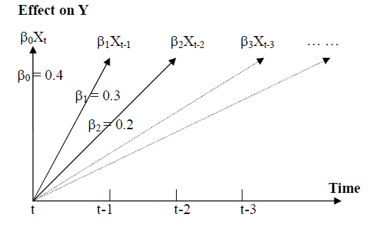

Applications where it can be applied:

1. Money creation process
2. Inflation process due to money supply
3. Productivity growth due to expenditure or investment.